System

S/N: 511025
Case stamped: Atari / 382
CPU board date seems to be 3682, which makes it a later 400, since it comes with 16K and apparently production ceased in 1982

Main Board

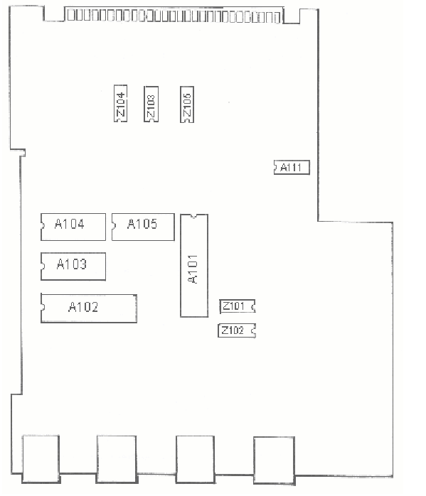

A103 – A105: ROM

A101 – POKEY

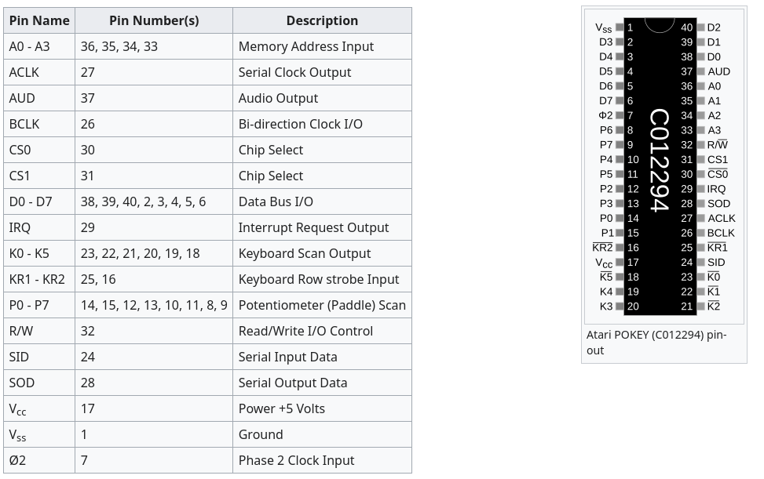

A102 – PIA
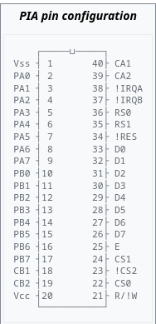

CPU Board

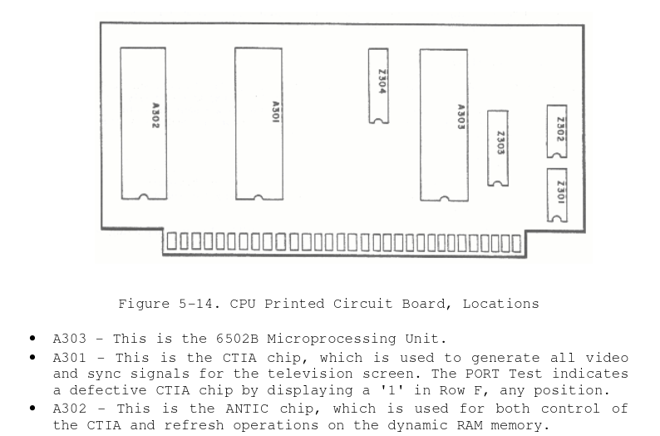

CPU Board – A302 (left) - C012296D-D1 – ANTIC
Alphanumeric Television Interface Controller
https://en.wikipedia.org/wiki/ANTIC

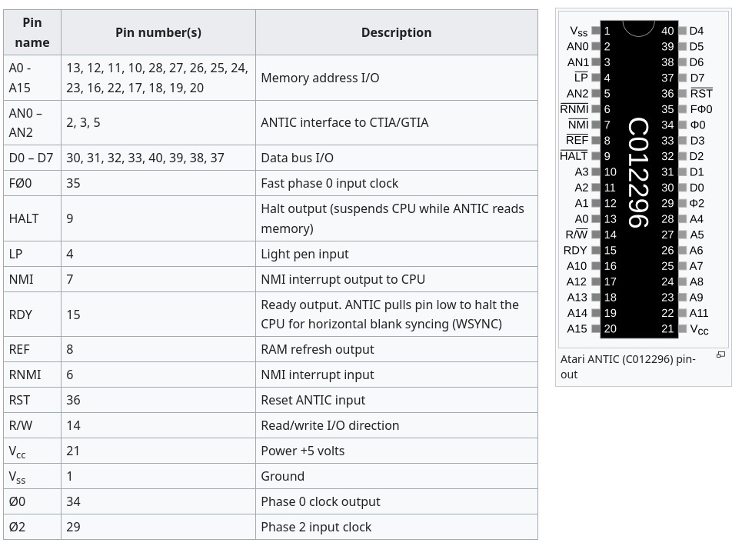

CPU board A301 (center) – C014805-01 – CTIA/GTIA
https://en.wikipedia.org/wiki/CTIA_and_GTIA
Color Television Interface Adapter
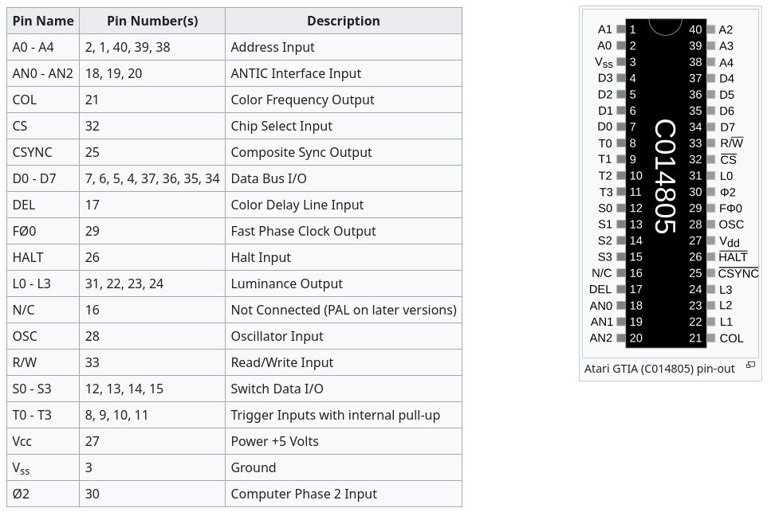

CPU Board – A303 (right) - C014377 / R6502 - CPU

